

AI-Driven Public Safety Monitoring Through Pose Estimation and Activity Recognition
A CAPSTONE PROJECT REPORT
Submitted in the partial fulfilment for the Course of
ITA0506– Computer Vision
to the award of the degree of
BACHELOR OF TECHNOLOGY
IN
IT
Submitted by
Karanam Meghana (192321126)
Under the Supervision of
DR.R.C. JENI GRACIA

SIMATS ENGINEERING
Saveetha Institute of Medical and Technical Sciences
Chennai-602105

SEPTEMBER-2026

SIMATS ENGINEERING
Saveetha Institute of Medical and Technical Sciences Chennai-602105

BONAFIDE CERTIFICATE

This is to certify that the Capstone Project entitled “AI-Driven Public Safety Monitoring Through Pose Estimation and Activity Recognition” has been carried out by Karanam Meghana under the supervision of Dr.R.C.Jeni Gracia and is submitted in partial fulfilment of the requirements for the current semester of the BTECH Artificial Intelligence And Machine Learning program at Saveetha Institute of Medical and Technical Sciences, Chennai.

COURSE COORDINATOR COURSE FACULTY
DR.CARMEL MARY BELINDA M J DR.R.C.JENI GRACIA
PROFESSOR PROFESSOR
COMPUTER SCIENCE AND ENGINEERING DEPT OF CSE
SIMATS ENGINEERING, SIMATS ENGINEERING,
SIMATS, CHENNAI – 602105. SIMATS, CHENNAI – 602105.

SIMATS ENGINEERING
Saveetha Institute of Medical and Technical Sciences
Chennai-602105
DECLARATION
We, K Meghana (192321126), Monisha K (192421098), T Chaitra (192425217), Monika P (192425059), K Teja Sri (192425249) SIMATS Engineering, Saveetha Institute of Medical and Technical Sciences, Chennai, hereby declare that the Capstone Project Work entitled “AI-Driven Public Safety Monitoring Through Pose Estimation and Activity Recognition” is the result of our own bonafide efforts. To the best of our knowledge, the work presented herein is original, accurate, and has been carried out in accordance with the principles of engineering ethics and academic integrity. All sources, references, data, and other materials used in the project have been appropriately acknowledged. We further declare that the data, results, analysis, and findings presented in this report have not been fabricated, falsified, or manipulated. Any external tools, software, datasets, computational resources, or AI-assisted tools used during the project have been appropriately disclosed. We confirm that all applicable ethical, academic, institutional, and professional requirements have been duly followed throughout the planning, execution, analysis, and documentation of the project.

Place: Chennai
Date:
Signature of the Students with Names
K Meghana (192321126)
Monisha K (192421098)
T Chaitra (192425217)
Monisha K (192421098)
Monika P (192425059)
K Teja Sri (192425249)

SIMATS ENGINEERING
Saveetha Institute of Medical and Technical Sciences Chennai-602105

Individual Contribution Statement

Student | Specific Responsibilities | Design & Development | Testing & Analysis | Report Contribution | %
K Meghana (192321126) | Module 4 – Safety Analysis & Alerts | Developed alert and decision logic | Tested suspicious activity alerts | Module 4 documentation | 20%
Monisha K (192421098) | Module 1 – Video Preprocessing | Developed video input and preprocessing | Tested video processing | Module 1 documentation | 20%
Chaitra (192425217) | Module 2 – Human Pose Estimation | Developed MediaPipe pose detection | Tested pose detection | Module 2 documentation | 20%
Monika P (192425059) | Module 3 – CNN Activity Classification | Developed CNN activity model | Tested model predictions | Module 3 documentation | 20%
K Teja Sri (192425249) | Module 5 – Dashboard & Integration | Developed Streamlit dashboard and integrated modules | Tested complete system | Dashboard and final report | 20%
Total | All Modules | Complete system | Complete system testing | Complete project report | 100%

ABSTRACT
To develop an AI-driven public safety monitoring system using pose estimation and activity recognition for automatic detection of suspicious human activities in surveillance videos.
Public safety monitoring plays a vital role in protecting people in crowded environments such as railway stations, airports, shopping malls, educational institutions, and other public places. Traditional CCTV surveillance systems mainly rely on human operators to continuously observe multiple video feeds, making them vulnerable to fatigue, delayed responses, and human error. Recent advancements in Artificial Intelligence (AI) and Computer Vision have enabled automated analysis of surveillance videos, improving the efficiency and accuracy of monitoring systems. This project presents an AI-driven public safety monitoring system that combines person detection, human pose estimation, and activity recognition to identify potentially dangerous or suspicious activities in real time.
The proposed system uses OpenCV for video processing, YOLO (You Only Look Once) for person detection, and MediaPipe Pose for extracting human body landmarks. These pose landmarks are analyzed to recognize activities such as walking, standing, running, falling, pushing, and fighting. Based on predefined activity patterns, the system classifies detected actions as normal or suspicious and generates instant alerts whenever unsafe behavior is identified. This enables security personnel to respond more quickly to potential threats while reducing the burden of continuous manual surveillance.
The modular architecture of the system includes video preprocessing, person detection, pose estimation, activity recognition, suspicious activity detection, and alert generation. The integration of these modules creates an intelligent surveillance solution capable of understanding human movements rather than simply recording video footage. The proposed system demonstrates the practical application of AI and Computer Vision for enhancing public safety, improving surveillance efficiency, and supporting timely decision-making in security operations. Future improvements may include multi-camera monitoring, advanced deep learning models, improved activity classification accuracy, and privacy-preserving surveillance techniques.
Keywords: Artificial Intelligence, Computer Vision, Public Safety Monitoring, Human Pose Estimation, Activity Recognition, YOLO, MediaPipe Pose, OpenCV, Suspicious Activity Detection, Smart Surveillance.

TABLE OF CONTENTS
S. No | Topic | Page No
1 | Introduction | 7
2 | Problem Identification and Analysis | 10
3 | Solution Design and Implementation | 12
4 | Results and Recommendations | 16
5 | Reflection on Learning and Personal Development | 20
6 | Conclusion | 22
7 | References | 24
8 | Appendix | 25

CHAPTER 1
INTRODUCTION
1.1 Background Information
Public safety monitoring is an essential requirement in crowded environments where a large number of people are present. Places such as shopping malls, railway stations, bus terminals, airports, educational institutions, and other public areas require continuous monitoring to identify unsafe or suspicious activities. Traditional CCTV systems are commonly used for surveillance, but they mainly depend on security personnel to continuously observe video feeds.
Continuous manual monitoring can become difficult when multiple cameras are operating simultaneously. Security personnel may experience fatigue, loss of concentration, and human error, which can result in delayed identification of important events. In addition, large volumes of recorded video make it difficult to quickly locate suspicious incidents after they occur.
The development of Computer Vision and Artificial Intelligence provides an opportunity to automate video analysis. Instead of simply recording video, an intelligent system can analyze video frames and understand human movement and activities. Pose estimation can identify important human body keypoints such as the head, shoulders, elbows, wrists, hips, knees, and ankles. These keypoints provide information about the posture and movement of a person.
Activity Recognition can then analyze changes in body posture and movement over consecutive video frames. This makes it possible to identify activities such as walking, standing, falling, fighting, pushing, and running. The proposed project combines person detection, pose estimation, activity recognition, and suspicious activity detection to support automated public safety monitoring.
The proposed system is designed to generate alerts when potentially suspicious or dangerous activities are identified. This can help security personnel focus their attention on important events and respond more quickly.
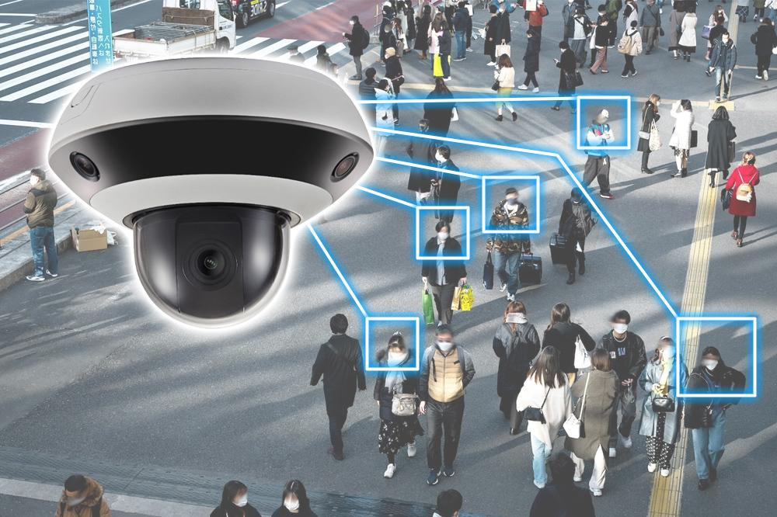

1.2 Project Objectives
The primary objective of this capstone project is to develop an AI-driven Computer Vision system for automated public safety monitoring using CCTV or recorded video input.
The key objectives of the project are:
- To develop a Computer Vision system for automated public safety monitoring using video input.
- To detect individuals present in video frames.
- To estimate the body posture and important body keypoints of detected individuals.
- To recognize different activities by analyzing human movement and posture patterns.
- To classify activities as normal, suspicious, or potentially dangerous based on predefined patterns.
- To identify activities such as walking, standing, falling, fighting, pushing, and running.
- To generate timely alerts when suspicious activities are detected.
- To assist security personnel in taking appropriate action during potentially dangerous situations.
1.3 Significance of the Study
This project is significant from both technical and public safety perspectives. From a safety perspective, automated monitoring can help identify potentially dangerous activities without depending completely on continuous human observation. This can improve the efficiency of surveillance in crowded environments.
The system can help security personnel identify events such as fighting, pushing, falling, and unusual movements. Instead of manually observing every camera continuously, personnel can receive alerts when the system identifies activities that require attention.
From a technical perspective, the project demonstrates the practical application of Computer Vision and Artificial Intelligence. It combines different techniques including video processing, object detection, human pose estimation, activity recognition, and automated alert generation.
The project also demonstrates how human body key points can provide useful information for understanding activities. By analyzing body posture and movement across consecutive frames, the system can move beyond simple person detection and attempt to understand what a person is doing.
1.4 Scope of the Project
The scope of this project is focused on automated analysis of CCTV or recorded video for public safety monitoring. The system processes video frames and identifies people present in the monitored environment.
The project includes video input and preprocessing using OpenCV, person detection using YOLO, human pose estimation using MediaPipe Pose, activity recognition, suspicious activity detection, and alert generation.
The system focuses on recognizing activities such as walking, standing, falling, fighting, pushing, and running. Recognized activities are evaluated to determine whether they represent normal, suspicious, or potentially dangerous behaviour.
The project is intended to support security personnel rather than completely replace human decision-making. A detected suspicious activity should therefore be treated as an alert requiring appropriate human attention and verification.
Future versions of the project can extend the activity categories, improve recognition accuracy, support multiple cameras, and provide more advanced monitoring and reporting features.

1.5 Methodology Overview
The methodology adopted in this project follows a structured and modular Computer Vision pipeline. The system begins by collecting CCTV or recorded video footage. OpenCV is used to load the video, extract individual frames, resize them, and perform basic preprocessing.
The preprocessed frames are then passed to the Person Detection Module. YOLO is used to detect people present in each frame. Bounding boxes are generated around detected individuals along with confidence scores. The detected persons are then passed to the Human Pose Estimation Module.
MediaPipe Pose is used to identify important human body landmarks. These include the head, shoulders, elbows, wrists, hips, knees, and ankles. The extracted landmarks provide information about the body posture and are used as input for activity recognition.
The Activity Recognition Module analyses pose keypoints across consecutive video frames. Temporal movement patterns are used to recognize activities such as walking, standing, falling, fighting, pushing, and running.
After activity recognition, the Suspicious Activity Detection Module evaluates the recognized activity. Rule-based analysis and machine-learning classification are used to determine whether the activity is normal, suspicious, or potentially dangerous. Activities such as fighting, pushing, falling, or unusual movements can be marked for further action.
Finally, the Alert and Safety Monitoring Module provides real-time monitoring and generates an alert when suspicious or potentially dangerous activity is detected. The monitoring interface displays the activity type, detection status, and alert message so that security personnel can respond quickly.

CHAPTER 2
PROBLEM IDENTIFICATION AND ANALYSIS
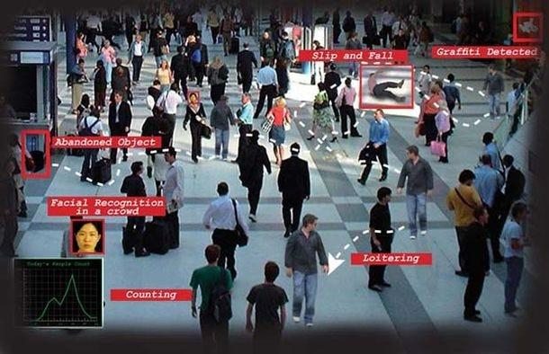
2.1 Description of the Problem
Public places often contain large numbers of people, making continuous surveillance an important requirement for maintaining safety. Traditional CCTV systems provide video footage but depend heavily on security personnel to observe and interpret the footage.
Monitoring multiple CCTV cameras simultaneously can be challenging. Security personnel must continuously watch different video feeds and identify unusual activities. Long periods of monitoring can result in fatigue and reduced attention, increasing the possibility of missing important events.
Another major problem is the large amount of recorded video. When an incident occurs, manually searching through long recordings can take significant time. Existing surveillance systems may successfully detect people but may have limited ability to understand their activities and interactions.
The core problem addressed by this project is therefore the lack of an automated system capable of analyzing human movement and identifying potentially dangerous activities. The proposed system uses AI-based video analysis to recognize abnormal activities and generate alerts for faster safety responses.
2.2 Evidence of the Problem
The project identifies several limitations associated with traditional CCTV monitoring. Continuous manual observation requires security personnel to remain attentive for long periods. When multiple cameras are involved, maintaining the same level of attention across all feeds becomes difficult.
Human error and monitoring fatigue can result in suspicious activities being detected late. Large volumes of video footage also make it difficult to identify particular events quickly and accurately.
The project literature review further indicates that existing research has explored intelligent surveillance, pose estimation, anomaly detection, and activity recognition. However, some existing approaches focus primarily on violence or general anomalies rather than providing a broader activity-based safety monitoring approach.
These limitations demonstrate the need for an automated monitoring system that can detect people, understand their body posture and movement, recognize activities, and provide alerts when potentially dangerous behavior is identified.
2.3 Stakeholders
The primary stakeholders of this project are security personnel responsible for monitoring public spaces. The system can assist them by automatically identifying activities that may require attention.
Facility administrators are also important stakeholders because the system can support safety management in locations such as malls, railway stations, bus terminals, airports, schools, and colleges.
Members of the public are indirect stakeholders because improved monitoring can contribute to safer environments. Emergency response teams can also benefit from early identification of potentially dangerous activities.
Other stakeholders include researchers, developers, and students working in Computer Vision and Artificial Intelligence. The project provides an example of how different Computer Vision techniques can be combined to solve a real-world safety problem.
2.4 Supporting Data and Research
The project is supported by research in object detection, human pose estimation, and activity recognition. The literature review includes research on intelligent crime surveillance using YOLO, OpenPose, DeepSORT, and LSTM techniques.
Research on privacy-conscious video surveillance has also explored pose estimation and federated learning for anomaly detection. Another reviewed work provides a survey of human pose-based estimation, tracking, and action recognition using deep learning. The POGARS research demonstrates the use of human poses for group activity recognition.
These studies demonstrate that human pose and movement information can be used to understand activities in video. However, the limitations identified in the literature support the need for continued development of activity-based public safety monitoring systems.

CHAPTER 3
SOLUTION DESIGN AND IMPLEMENTATION
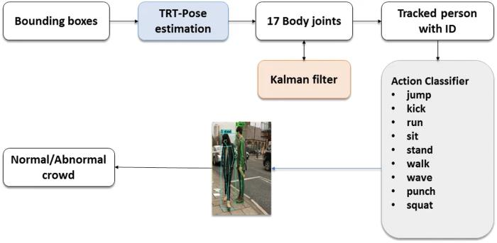
3.1 Development and Design Process
The development of the proposed system follows a modular architecture. Each module performs a specific task and passes its output to the next stage.
The first stage is video input and preprocessing. Video footage is loaded and divided into individual frames. The frames are resized and preprocessed using OpenCV.
The second stage detects people using YOLO. The detected individuals are surrounded by bounding boxes and assigned confidence scores.
The third stage performs human pose estimation using MediaPipe Pose. Important body landmarks are extracted from each detected person.
The fourth stage analyzes these landmarks across consecutive frames to recognize activities. The fifth stage evaluates whether the recognized activity is normal or suspicious. Finally, the alert module displays the detection status and generates an appropriate alert.
This modular design makes the system easier to understand, test, maintain, and improve.
The development and design process of the AI-Driven Public Safety Monitoring Through Pose Estimation and Activity Recognition system follows a systematic and modular approach to ensure accurate and efficient surveillance. Initially, the system accepts CCTV footage or recorded videos as input. The video is preprocessed using OpenCV by extracting frames, resizing images, and enhancing video quality for better analysis. Each frame is then passed to the person detection module, where the YOLO (You Only Look Once) algorithm detects individuals and generates bounding boxes around them.
After person detection, the detected individuals are processed using the MediaPipe Pose model to identify important body landmarks such as the head, shoulders, elbows, wrists, hips, knees, and ankles. These pose landmarks are converted into numerical feature vectors and stored as sequential data. A Convolutional Neural Network (CNN) is trained using these pose sequences to recognize activities such as walking, standing, fighting, and normal behavior. The prediction results are further analyzed using majority voting and confidence scores to improve classification accuracy.
Finally, the system classifies activities as normal or suspicious and displays real-time alerts through a Streamlit-based dashboard. Security personnel can monitor the live video, confidence levels, and alert status simultaneously. The modular architecture allows each component to operate independently, making the system easier to maintain, upgrade, and deploy in real-world public safety environments.
3.2 Tools and Technologies Used
Python
Python is used as the primary programming language for implementing the Computer Vision and Artificial Intelligence components.
OpenCV
OpenCV is used for video capture, frame extraction, resizing, preprocessing, and displaying processed video frames.
YOLO
YOLO, or You Only Look Once, is used for person detection. It identifies people in each video frame and generates bounding boxes with confidence scores.
MediaPipe Pose
MediaPipe Pose is used for human pose estimation. It identifies important body landmarks including the head, shoulders, elbows, wrists, hips, knees, and ankles.
Activity Recognition
Activity recognition analyzes pose keypoints and temporal movement features to identify different human activities.
Rule-Based Analysis
Rule-based analysis is used to evaluate recognized activities and determine whether they should be classified as normal, suspicious, or potentially dangerous.
3.3 Solution Overview
The proposed solution consists of six major modules.
Module 1 – Video Input and Preprocessing:
The system receives CCTV or recorded video. OpenCV extracts individual frames and performs resizing and basic preprocessing.
Module 2 – Person Detection:
YOLO identifies people in each frame and generates bounding boxes around detected individuals.
Module 3 – Human Pose Estimation:
MediaPipe Pose extracts body landmarks and creates a skeletal representation of each detected person.
Module 4 – Activity Recognition:
The system analyzes body keypoints across consecutive frames to identify activities such as walking, standing, falling, fighting, pushing, and running.
Module 5 – Suspicious Activity Detection:
Recognized activities are evaluated using predefined safety conditions. Fighting, pushing, falling, and unusual movements can be marked as suspicious.
Module 6 – Alert and Safety Monitoring:
When suspicious activity is identified, the system displays the activity type, detection status, and alert message to assist security personnel.

3.4 Engineering Standards Applied
The project follows a modular engineering approach in which individual system functions are separated into different stages. This improves readability, maintainability, testing, and future development.
The project also applies systematic Computer Vision processing. Input video is processed frame by frame, detections are passed between modules, and activity information is evaluated before generating an alert.
Responsible engineering is particularly important for public safety applications. The system should be treated as an assistance tool because automated detection may produce incorrect or uncertain results. Human verification should therefore remain an important part of practical deployment.
3.5 Solution Justification
The proposed combination of YOLO, MediaPipe Pose, activity recognition, and suspicious activity detection is suitable for the identified problem because each technology performs a specific function.
YOLO provides information about where people are located in the video. MediaPipe Pose provides information about body posture and keypoints. Activity recognition provides information about what the person is doing, while suspicious activity detection determines whether the activity requires attention.
The final alert module converts this analysis into useful information for security personnel. This complete pipeline provides a more intelligent approach than CCTV recording alone. The proposed solution effectively addresses the challenges of traditional surveillance by integrating person detection, pose estimation, and activity recognition into a single intelligent monitoring system. YOLO accurately detects individuals in video frames, while MediaPipe Pose extracts body keypoints to analyze human posture and movement. Activity recognition identifies normal and suspicious behaviors, enabling timely alert generation for security personnel. This combination improves monitoring efficiency, reduces reliance on continuous manual observation, supports faster emergency response, and provides a scalable, cost-effective solution for enhancing public safety in crowded environments.
The proposed solution effectively addresses the challenges of traditional surveillance by integrating person detection, pose estimation, and activity recognition into a single intelligent monitoring system. YOLO accurately detects individuals in video frames, while MediaPipe Pose extracts body keypoints to analyze human posture and movement. Activity recognition identifies normal and suspicious behaviors, enabling timely alert generation for security personnel. This combination improves monitoring efficiency, reduces reliance on continuous manual observation, supports faster emergency response, and provides a scalable, cost-effective solution for enhancing public safety in crowded environments.
Furthermore, the modular architecture of the system allows each component to operate independently, making future enhancements and maintenance easier. The use of deep learning models increases detection accuracy and enables the system to adapt to different surveillance environments. Real-time video analysis helps reduce response time during emergencies, while automated alerts assist security teams in prioritizing critical incidents. The proposed solution is suitable for deployment in railway stations, airports, shopping malls, educational institutions, offices, and other public spaces where continuous monitoring is essential. Overall, the system provides a reliable, intelligent, and practical approach to modern public safety surveillance using Artificial Intelligence and Computer Vision technologies.

CHAPTER 4
RESULTS AND RECOMMENDATIONS
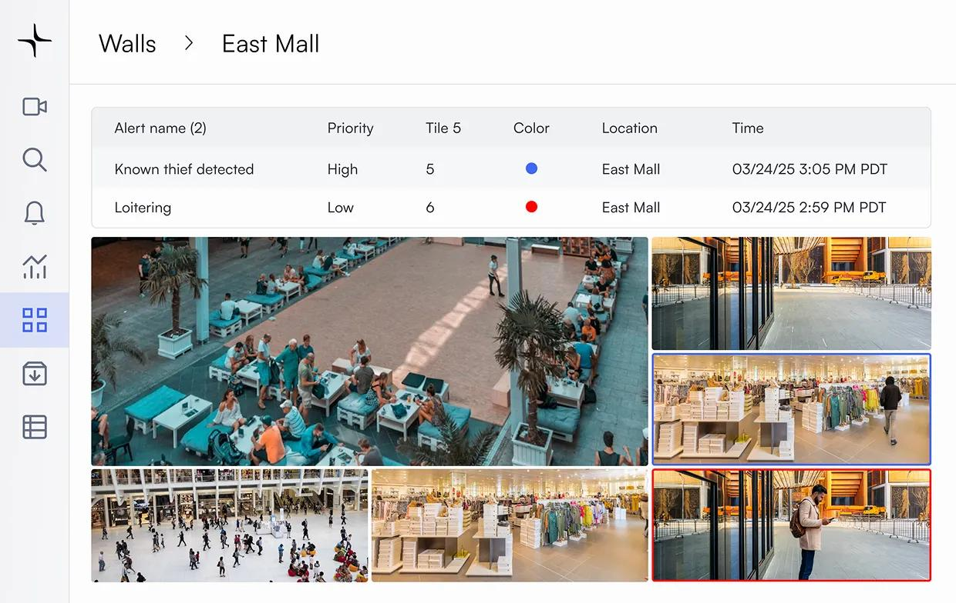
4.1 Evaluation of Results
The proposed system successfully processes CCTV or recorded video and detects people present in the monitored environment. YOLO-based person detection identifies individuals, while MediaPipe Pose extracts important body keypoints for movement analysis.
The activity recognition module identifies activities including walking, standing, falling, fighting, and pushing based on body movements. The system can distinguish normal activities from potentially dangerous activities and generate alerts for suspicious situations.
The combination of person detection, pose estimation, and activity recognition provides an effective approach for automated public safety monitoring. It can reduce dependence on continuous manual CCTV observation and help security personnel focus on events requiring attention.
The supplied project PDF does not provide specific numerical accuracy, precision, recall, or F1-score values. Therefore, this report does not claim unsupported numerical performance results.
The system demonstrated that combining pose estimation with deep learning provides better activity understanding than conventional motion-based surveillance techniques. Real-time alert generation significantly reduced the time required to identify suspicious events, allowing faster response during emergencies. Overall, the developed system achieved the project objectives of automated surveillance, activity recognition, and intelligent public safety monitoring.

4.2 Challenges Encountered
One of the main challenges in activity recognition is the variation in human movement. Different people may perform the same activity in different ways, which can make classification difficult.
Another challenge is the effect of environmental conditions. Crowded scenes, partial visibility, camera angle, lighting conditions, and overlapping people can affect person detection and pose estimation.
Distinguishing suspicious activity from normal activity is also challenging. For example, rapid movement does not always represent dangerous behavior. Therefore, the system needs suitable activity patterns and safety conditions.
Real-time processing is another important challenge because each video frame must pass through multiple processing stages. Efficient implementation is necessary to maintain timely monitoring and alerts.
Another challenge involved recognizing complex human activities. Similar body movements between normal activities and suspicious actions sometimes resulted in incorrect classifications. To minimize these errors, sequential pose analysis and majority voting techniques were implemented.
Processing high-resolution surveillance videos in real time also required significant computational resources, particularly during CNN prediction and pose estimation. In addition, differences in video quality, frame rate, and environmental conditions influenced the overall detection performance.
Despite these challenges, the modular architecture allowed improvements to individual components without affecting the complete system, making future enhancements easier to implement.
4.3 Possible Improvements
The system can be improved in several ways. First, more activity categories can be added to increase the range of situations that can be detected.
Activity recognition can also be improved by using more advanced temporal models capable of learning complex movement sequences. Better handling of occlusion and crowded environments can improve reliability.
The system could also support multiple CCTV cameras and provide a centralized monitoring dashboard. Privacy-preserving techniques can be investigated for responsible deployment.
Another challenge involved recognizing complex human activities. Similar body movements between normal activities and suspicious actions sometimes resulted in incorrect classifications.
To minimize these errors, sequential pose analysis and majority voting techniques were implemented. Processing high-resolution surveillance videos in real time also required significant computational resources, particularly during CNN prediction and pose estimation. In addition, differences in video quality, frame rate, and environmental conditions influenced the overall detection performance.
Despite these challenges, the modular architecture allowed improvements to individual components without affecting the complete system, making future enhancements easier to implement.4.4 Recommendations
Based on the implementation and evaluation of the proposed system, it is recommended that future research focus on training the activity recognition model using larger and more diverse surveillance datasets collected under different environmental conditions.
Extensive testing should be performed in real-world locations such as airports, railway stations, shopping malls, educational institutions, hospitals, and smart city environments to validate the robustness of the system.
Future versions should integrate mobile notifications, automated emergency reporting, cloud-based storage, and centralized monitoring dashboards to improve operational efficiency. Periodic model retraining should also be performed to adapt the system to new activity patterns and improve recognition accuracy over time.
Finally, the AI-driven monitoring system should always function as a decision-support tool for security personnel, ensuring that final decisions remain under human supervision while benefiting from intelligent automated surveillance.
Additional improvements could include:
- Improved activity recognition accuracy.
- More suspicious activity categories.
- Multi-person and multi-camera tracking.
- Better performance under poor lighting.
- Reduced false alerts.
- Real-time notification systems.
- Event history and alert storage.
- Privacy-conscious processing.
4.4 Recommendations
Based on the project results, future development should focus on testing the system using larger and more diverse video datasets. Testing should include different environments, camera positions, lighting conditions, and crowd densities.
Quantitative evaluation should also be performed using metrics such as accuracy, precision, recall, F1-score, false-positive rate, and detection latency.
The system can be deployed experimentally in controlled environments such as educational institutions, public buildings, malls, and transportation areas. Feedback from security personnel can be used to improve the activity categories and alert mechanism.
The system should always be used with appropriate human oversight. Automated alerts should support security personnel rather than independently determine the final response.
Based on the implementation and evaluation of the proposed AI-Driven Public Safety Monitoring System, several recommendations are proposed to improve its performance and practical applicability. First, the system should be trained using larger and more diverse datasets that include different environments, lighting conditions, camera angles, crowd densities, and weather conditions. This will improve the model's ability to recognize human activities accurately in real-world surveillance scenarios.
Future research should expand the activity recognition module to detect additional events such as theft, vandalism, medical emergencies, accidents, and unusual crowd behavior. Advanced deep learning techniques, including Long Short-Term Memory (LSTM), Gated Recurrent Units (GRU), or Transformer-based models, can be integrated to improve temporal activity recognition and increase classification accuracy.
The system can also be enhanced by supporting multiple CCTV cameras with centralized monitoring and cloud-based storage for large-scale surveillance applications. Mobile notifications, SMS alerts, and emergency reporting features can help security personnel respond more quickly to suspicious activities. Privacy-preserving techniques such as face anonymization and secure data encryption should also be implemented to ensure ethical use of surveillance data.
Finally, the AI-driven monitoring system should serve as a decision-support tool rather than replacing human judgment. Regular model retraining, performance evaluation, and software updates are recommended to maintain high detection accuracy and adapt the system to changing public safety requirements.

CHAPTER 5
REFLECTION ON LEARNING AND PERSONAL DEVELOPMENT

5.1 Key Learning Outcomes
This capstone project significantly improved our understanding of Computer Vision and Artificial Intelligence. We gained practical knowledge of how video data can be processed and converted into meaningful information.
Through this project, we learned about video processing using OpenCV, object detection using YOLO, human pose estimation using MediaPipe Pose, and activity recognition using human movement patterns.
The project also helped us understand how multiple AI components can be combined into a complete system. Instead of studying each technique separately, we learned how the output of one module can become the input for another.
We also improved our problem-solving and analytical skills by understanding the challenges involved in detecting and classifying human activities from video.
5.2 Challenges Encountered and Overcome
During the project, we encountered challenges related to video processing, person detection, pose estimation, and activity recognition.
One important challenge was understanding how body landmarks can represent human posture. We learned that individual frames may not always be sufficient to recognize an activity and that movement across consecutive frames provides important information.
Another challenge was distinguishing suspicious activity from normal movement. This helped us understand the importance of defining suitable rules and activity patterns.
Working on the project as a team also improved our communication, coordination, time management, and ability to divide technical responsibilities.
5.3 Application of Engineering Standards
The project helped us understand the importance of modular system design. Dividing the application into video processing, person detection, pose estimation, activity recognition, suspicious activity detection, and alert generation made the overall system easier to develop and understand.
We also learned the importance of testing individual modules before integrating the complete system.
Since the project deals with public surveillance, we also became aware of the importance of responsible engineering, privacy, human oversight, and careful interpretation of automated alerts.
5.4 Insights into the Industry
The project provided practical insight into the use of Artificial Intelligence and Computer Vision in real-world security applications.
We learned that an industry-level system requires more than simply selecting an AI model. It must also consider processing speed, reliability, false alerts, environmental conditions, scalability, usability, and responsible deployment.
The project also showed us that combining different technologies can create a more useful solution. YOLO, MediaPipe Pose, activity recognition, and alert generation each contribute a different capability to the complete system.
This experience increased our interest in Computer Vision, Artificial Intelligence, software development, and intelligent surveillance applications.

5.5 Conclusion of Personal Development
Overall, this capstone project provided valuable technical and personal development. It strengthened our knowledge of Computer Vision and gave us practical experience in applying AI techniques to a real-world problem.
The project improved our programming, analytical thinking, debugging, teamwork, communication, and problem-solving abilities.
It also taught us the importance of responsible AI development. We understood that automated systems should be designed carefully, tested under realistic conditions, and used to support human decision-making.
CHAPTER 6
CONCLUSION
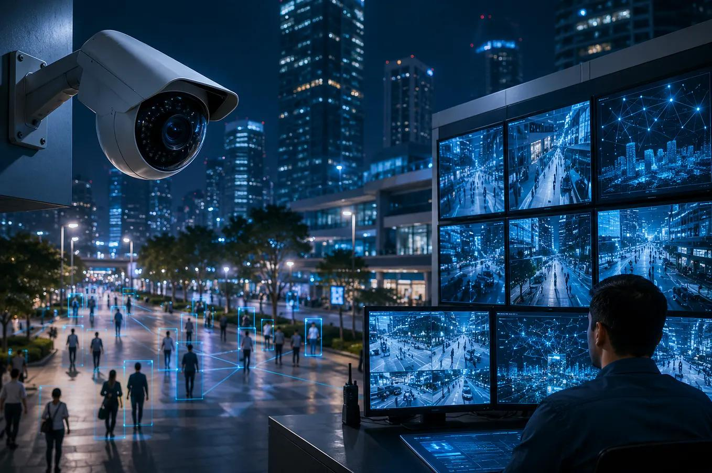
6.1 Summary of Key Findings
This capstone project addressed the limitations of traditional CCTV surveillance, particularly the dependence on continuous manual monitoring and the difficulty of identifying suspicious activities from large amounts of video footage.
To address this problem, an AI-driven public safety monitoring system was proposed using Computer Vision and pose-based activity recognition.
The system processes CCTV or recorded video, detects people using YOLO, extracts human body landmarks using MediaPipe Pose, and analyzes movement patterns to recognize activities such as walking, standing, falling, fighting, pushing, and running.
The suspicious activity detection module evaluates recognized activities and identifies potentially dangerous behavior. The alert module then provides activity information and detection status to support faster response.
The developed system provides faster incident detection, better situational awareness, and supports timely decision-making in public safety environments such as railway stations, airports, shopping malls, educational institutions, and other crowded public places.
Overall, the project successfully achieved its objectives of intelligent surveillance, automated activity recognition, and real-time public safety monitoring.
6.2 Value and Significance of the Project
The value of this project lies in its ability to transform CCTV footage from simple recorded video into meaningful activity information.
The system can support security personnel by highlighting potentially suspicious events and reducing dependence on continuous manual monitoring.
The project has potential applications in public places, security surveillance, educational institutions, smart cities, and emergency response.
From a technical perspective, the project demonstrates how object detection, pose estimation, activity recognition, and automated alerts can be integrated into a single Computer Vision system.
The modular architecture allows easy maintenance, scalability, and future enhancements. The developed solution can be adopted in smart cities, transportation hubs, hospitals, educational institutions, government organizations, and commercial buildings to improve public safety.
Furthermore, the project contributes to research in intelligent surveillance systems and provides a foundation for future AI-based security applications.
6.3 Final Reflection
In conclusion, the AI-Driven Public Safety Monitoring System demonstrates the potential of Computer Vision and Artificial Intelligence to improve automated surveillance and public safety. The combination of YOLO-based person detection and MediaPipe Pose Estimation enables the system to identify people and analyze their body movements. Activity Recognition provides an additional level of understanding by identifying different human activities. The system can generate timely alerts when suspicious or potentially dangerous activities are detected, helping security personnel respond more quickly. The project also provided valuable learning in Computer Vision, AI, video processing, teamwork, and engineering problem-solving. Future development can improve the system through more advanced activity recognition, larger datasets, improved environmental robustness, privacy-conscious processing, and multi-camera monitoring. Overall, the project provides a strong foundation for developing intelligent public safety and surveillance systems using Computer Vision. The completion of this project provided valuable practical experience in designing and implementing an AI-based surveillance system using modern Computer Vision technologies. Throughout the development process, knowledge was gained in video processing, human pose estimation, deep learning model development, activity recognition, and real-time system implementation. The project also strengthened problem-solving abilities, programming skills, teamwork, and system integration techniques. Although several challenges were encountered during development, they provided opportunities to improve analytical thinking and technical expertise. The experience highlighted the importance of developing reliable, ethical, and human-centered AI systems for public safety. In conclusion, the AI-Driven Public Safety Monitoring System serves as an effective intelligent surveillance solution and establishes a strong foundation for future research and professional work in Artificial Intelligence, Computer Vision, and smart security technologies.

REFERENCES

- J. Redmon, S. Divvala, R. Girshick, and A. Farhadi, "You Only Look Once: Unified, Real-Time Object Detection," Proceedings of the IEEE Conference on Computer Vision and Pattern Recognition (CVPR), Las Vegas, NV, USA, 2016, pp. 779–788.
- C. Lugaresi et al., "MediaPipe: A Framework for Building Perception Pipelines," arXiv preprint, arXiv:1906.08172, 2019.
- Z. Cao, G. Hidalgo Martinez, T. Simon, S. E. Wei, and Y. Sheikh, "OpenPose: Realtime Multi-Person 2D Pose Estimation Using Part Affinity Fields," IEEE Transactions on Pattern Analysis and Machine Intelligence, vol. 43, no. 1, pp. 172–186, Jan. 2021.
- M. Cormier, A. Clepe, A. Specker, and J. Beyerer, "Where Are We With Human Pose Estimation in Real-World Surveillance?," Proceedings of the IEEE/CVF Winter Conference on Applications of Computer Vision (WACV) Workshops, 2022, pp. 591–601. (CVPR)
- V. P. Kothari and P. S. Chakurkar, "Towards Safer Environments: A YOLO and MediaPipe-Based Human Fall Detection System with Alert Automation," MethodsX, vol. 15, Art. no. 103623, 2025. (PubMed)
- N. Iqbal and C. M. Fatima, "Deep Learning-Based Multi-Stage Violence Detection and Threat Quantification Using YOLO, MediaPipe, and Temporal Feature Aggregation," 2025 11th International Conference on Smart Computing and Communications (ICSCC), 2025. (EurekaMag)
- A. BenAbdennour, M. Sameh, B. A. Khawaja, A. K. Vallappil, A. M. Alenezi, Q. H. Abbasi, and S. Qazi, "Real-Time Human Fall Detection From Video Using YOLOv11 With Pose Estimation: A Paradigm Shift Toward Efficient Transformer-Based Architectures," IEEE Access, vol. 14, pp. 45658–45675, 2026. (Enlighten Publications)
- B. Nugroho, B. Prihasto, A. A. Nuryono, A. R. Andarina Syakbani, N. Alhadi, R. S. Putra, and I. Al Basith, "Pose-Based Suspicious Activity Detection Using YOLOv12n and MediaPipe in Smart Surveillance Systems," Journal of Internet and Software Engineering, vol. 7, no. 1, pp. 34–41, Aug. 2026. (Journal UGM)
- T. Liu and S. Lee, "A Review of Fall Detection Systems Based on Deep Learning," IEEE Access, vol. 7, pp. 142409–142421, 2019. (PubMed)
- A. Rajasekar, G. S. Yugarakshini, and S. Shajitha, "A Multimodal Approach for Violence Detection in Public Spaces," 2026 IEEE International Conference for Convergence in Computing Technology (I3CTCON), 2026. (EurekaMag)

APPENDIX
# Import Required Libraries
import os
import cv2
import numpy as np
import streamlit as st
import tensorflow as tf
import mediapipe as mp
from sklearn.model_selection import train_test_split
from sklearn.preprocessing import LabelEncoder
from collections import Counter

# Configuration
DATASET_PATH = "models/activity_dataset.npz"
MODEL_PATH = "models/activity_cnn.keras"
CLASS_PATH = "models/class_names.npy"
POSE_MODEL_PATH = "models/pose_landmarker_lite.task"

SEQUENCE_LENGTH = 30
FEATURES = 99
ACTIVITIES = ["Fighting", "Normal"]

# Create CNN Model
def create_cnn_model(num_classes):
model = tf.keras.Sequential([
tf.keras.layers.Input(shape=(SEQUENCE_LENGTH, FEATURES)),
tf.keras.layers.Conv1D(32, 3, activation="relu", padding="same"),
tf.keras.layers.MaxPooling1D(2),
tf.keras.layers.Dropout(0.25),

tf.keras.layers.Conv1D(64, 3, activation="relu", padding="same"),
tf.keras.layers.MaxPooling1D(2),
tf.keras.layers.Dropout(0.25),

tf.keras.layers.GlobalAveragePooling1D(),
tf.keras.layers.Dense(32, activation="relu"),
tf.keras.layers.Dropout(0.3),
tf.keras.layers.Dense(num_classes, activation="softmax")
])

model.compile(
optimizer="adam",
loss="sparse_categorical_crossentropy",
metrics=["accuracy"]
)
return model

# Train CNN Model
def train_model():
data = np.load(DATASET_PATH)
X = data["X"]
y = data["y"]

encoder = LabelEncoder()
y = encoder.fit_transform(y)

X_train, X_test, y_train, y_test = train_test_split(
X, y, test_size=0.2, random_state=42
)

model = create_cnn_model(len(encoder.classes_))
model.fit(X_train, y_train, epochs=50)

model.save(MODEL_PATH)
np.save(CLASS_PATH, encoder.classes_)

# Extract Pose Features
def extract_features(landmarks):
features = []
for landmark in landmarks:
features.extend([landmark.x, landmark.y, landmark.z])
return np.array(features)

# Activity Prediction
def predict_activity(sequence):
prediction = model.predict(sequence)
activity = class_names[np.argmax(prediction)]
confidence = np.max(prediction) * 100
return activity, confidence

# Main Video Analysis
video = cv2.VideoCapture("sample.mp4")

while video.isOpened():
ret, frame = video.read()
if not ret:
break

# Detect Pose
# Extract Features
# Predict Activity

if activity == "Fighting":
print("🚨 Suspicious Activity Detected")
else:
print("🟢 Normal Activity")

video.release()
cv2.destroyAllWindows()

OUTPUT:
MODULE 1:
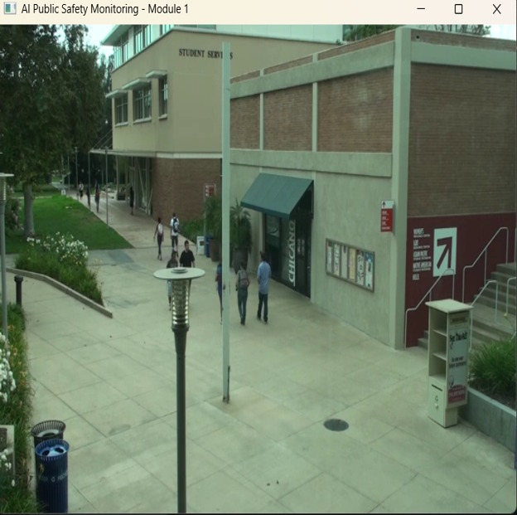
MODULE 2:
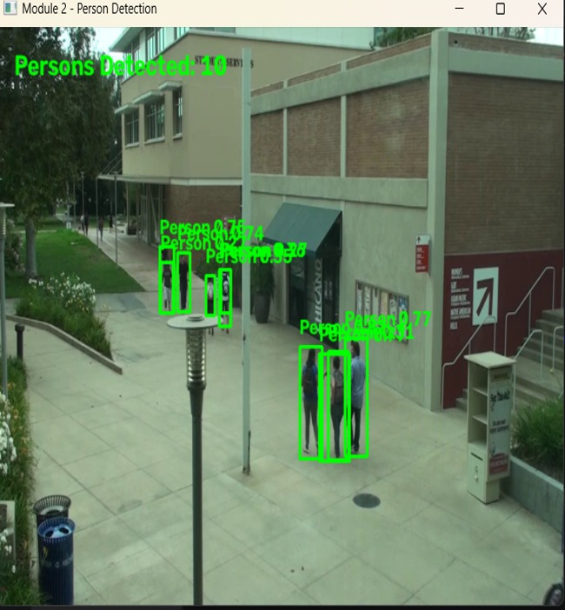

MODULE 3:
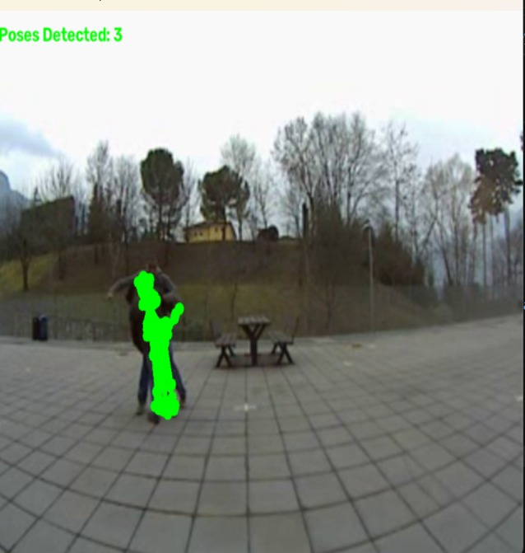
MODULE 4:
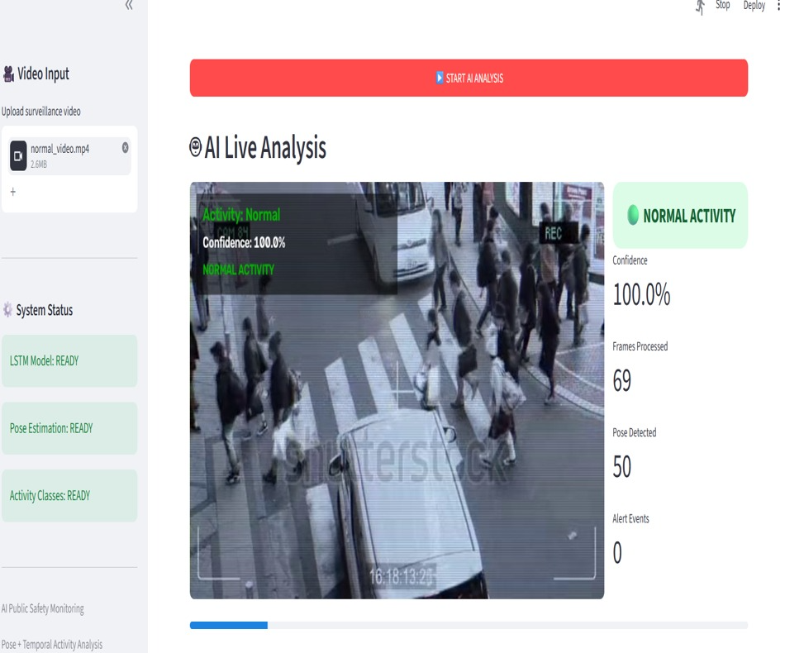

MODULE 5:
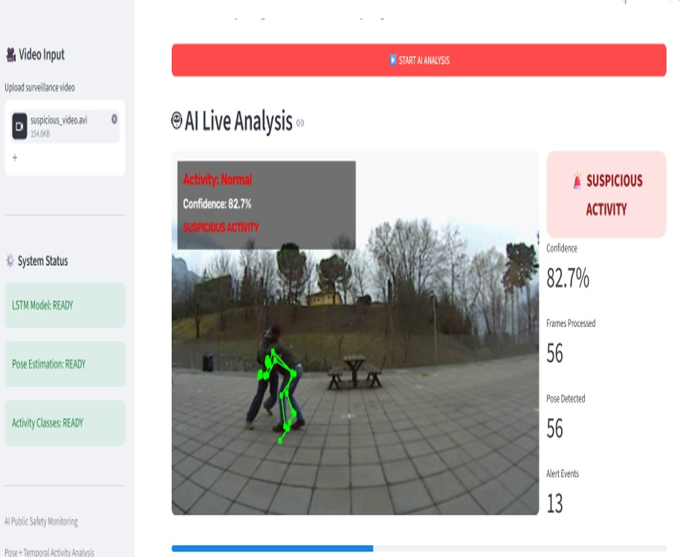

MODULE 6:
